Marconi Project
Data Transmission via Transparent Wireless Modem

Document NO: 101
Version: 2

Fourth Year Design Project
Department of Electrical and Computer Engineering
University of Waterloo
200 University Ave. W., Waterloo, ON

Project Contact: | Vincent G. Liu
Email: | UWFYDP@Gmail.com
Phone: | 416.602.3831

TABLE OF CONTENTS

EXECUTIVE SUMMARY 3
THE MARCONI DESIGN TEAM 4
MARCONI PROJECT FEATURES AND BENEFITS 6
PROGRAM DEVELOPMENT AND OPERATIONS 7
Phase 1: Needs Assessment (June – August 2004) 7
Phase 2: Requirements Definition (September – October 2004) 7
Phase 3: Hardware Implementation (November 2004 – February 2005) 9
Phase 4: Design Symposium (February 2006) 9
Phase 5: Good Will Implementation and Education 9
FINANCIAL PROJECTIONS 10
SPONSORSHIP PACKAGES AND BENEFITS 11

EXECUTIVE SUMMARY

Marconi Project is a part of the University of Waterloo Department of Electrical and Computer Engineering Undergraduate 4th year design symposium.

The main purpose of the 4th year design project is to give students an opportunity to work in a team environment and be exposed to all the problems that exist in the “real world” and learn to tackle them. Students are encouraged to come up with an educational and marketable idea and complete it.

This project involves the use of a Transparent Wireless modem to transfer data via amateur radio. This idea was developed in conjunction with a non-profit organization in attempt to aid third world countries in the areas of wireless communication and education. The Transparent Wireless Modem along with a suitable radio device gives rural areas the ability to communicate with each other and share vital information making the community synergetic. The finished product and the design will be turn over to the local engineers.

Since the project is entirely academic and non-profit, the fundraising aspect of the project is a major factor that will govern the completion and success of the project. The project team also hopes to establish mutually beneficial relationships with project sponsors. This proposal highlights the goals and the needs of the project as well as the various benefits that the sponsors are exposed to by working in conjunction with the Marconi project team and the University of Waterloo.

THE MARCONI DESIGN TEAM

Stefan Janhunen

Algorithm Lead
Candidate for bachelor of applied sciences, 4th year electrical engineering, University of Waterloo

Mr. Janhunen has industry experience in embedded hardware, software,
and signal processing. Over the past several years, he has worked with
various hardware and software development teams at Research In Motion, maker of the Blackberry wireless handheld.

Leveraging this experience, he will be contributing to the system design and algorithm development for this project.

Aaron Cheung

Hardware Lead
Candidate for bachelor of applied sciences, 4th year electrical engineering, University of Waterloo

Mr. Cheung will assist the team in designing and troubleshooting the required hardware. Some major areas include test board development, component layout, initial testing, and firmware development.
Mr. Cheung has a strong interest in a wide variety of areas. In his
previous work terms, he has spent time with manufacturing companies
such as General Motors of Canada, L-3 Wescam, and ArvinMeritor. He
has contributed his talents in improving manufacturing efficiencies
and product quality through PLC programming, product tooling research,
power quality studies, quality assurance, and various case studies.

Tom S. Wu

Firmware Lead
Candidate for bachelor of applied sciences, 4th year electrical engineering, University of Waterloo

Mr. Tom Wu brings to the team industry experience in embedded systems. Recently, he has been responsible for the software support of a worldwide LCD TV project for a leading Japanese manufacturer through Genesis Microchip. Prior to that, he has been employed at Research In Motion and the Canadian Space Agency.
During his 4 years at the University of Waterloo, Mr. Wu has pursued
his interests in the areas of ASIC Design and software algorithms.

Vincent G. Liu

Marketing / Relations Manager
Candidate for bachelor of applied sciences, 4th year electrical engineering, University of Waterloo

Prior to joining the Marconi project team, Mr. Liu worked in the marketing department of several firms in the private and public sector on his coop terms while perusing his bachelor’s degree in electrical engineering. His past employers include IEEE, Bell Mobility, BMO Financial Group and Ontario Power Generation Inc.

Mr. Liu is experienced in the areas of Customer Relationship Managing, and sales and marketing in the medium/small business segment.

MARCONI PROJECT FEATURES AND BENEFITS

FEATURES | BENEFITS
Transparent Wireless Modem | The modem can be implemented on any commercial radio handset seamlessly and with ease. This means flexibility, scalability, and lower implementation cost.
Range of the device is variable depending on the type of application | The transparent wireless modem can be implemented in different geographic regions.
Error correction algorithm increases speed and efficiency of data transfer while protecting it from external interference | The advanced error correction algorithm embedded in the device allows the modem to recover signals and correct errors of data transfer when exposed to high level of interference.
Battery powered, low power device serves you longer, uninterrupted | Unlike many other wireless modems, the Marconi project transparent wireless modem does not need an AC power source. A commercial alkaline battery will provide enough electrons to power the device.
Extremely compact device that can be attached almost anywhere | The compact size of the modem (xxx cm by xxx cm) allows the device to be attached to any surface very easily.
Low implementation cost | Unlike most other wireless solutions, the cost to implement Marconi project is low therefore, making it an ideal solution for undeveloped countries.

PROGRAM DEVELOPMENT AND OPERATIONS

This section provides an overview of the proposed project phases.

Phase 1: Needs Assessment (June – August 2004)
This phase of the project was conducted very thoroughly. The group had to decide on the focus of the project and what needs it is answering. Discussion were held with a non-profit organization dedicated to helping third world countries achieve higher standard of living hoping to clarify the needs.

After thorough research, it was concluded that most third world countries are in desperate need for communication. The Marconi project will give people living in that area a chance to connect with the outside world and more importantly learn about the concepts of wireless communication.

Phase 2: Requirements Definition (September – October 2004)
Business, functional and technical requirements in the following areas are determined in this section of the report:

Organization
- Infrastructure (locations and resources)
- Expertise in the areas of hardware, software, algorithm and marketing was recruited to the team
- Most of the hardware resources will be purchased
- University of Waterloo will provide additional expertise in the area, as well as, laboratory equipment usage.
- Integration alternatives & strategy
- The project will be divided into sections. Hardware, software, and market development will happen concurrently.
- Training program recommendations
- The last two hours of the weekly status update meeting will be used for education and discussion of the topic areas
- Marketing & communication considerations
- The marketing / relations manager will manage all marketing aspect of the project while each group member is involved with the process.
- Tools such as MSN Messenger, SKYPE online conference, Web Blog, and Gmail are used to facilitate the communication between group members.
- A marketing website has been created to give an online tour of MARCONI and the history and tradition of the University of Waterloo 4th year design project.

Process
- Process requirements
- A thorough project plan has been created to ensure all the milestone of the project is reached. This will ensure the timely completion of the project.
- Work load assignment
- Each group member will be assigned a different aspect of the project so the development can occur in parallel. During the weekly status meeting the member will present their results while educating the other members of the group on their area. This will ensure each group member’s full understanding of the project.
- Implementation details and Quality control
- The implementation of the project requires close cooperation of each of the group members. Errors caused by miscommunication can delay the progress of the project significantly.
- The Subversion Version Control tool has been implemented to ensure that the versions are kept current. The tool also allows easy backup and restore of data.

Technology
- DSP
- The TI Digital Signal Processor (DSP) has been chosen to be the core processor of the device.
- Audio Codec
- The TI Audio Codec will convert analog signals to digital signals and vice versa.
- Board Selection
- Stefan and Aaron – please email me the board you guys chose
- Design Tools / Debugging Tools
- Stefan – can you please email me a list of the design and debug tools?

Phase 3: Hardware Implementation (November 2004 – February 2005)
The design of the device will be thoroughly tested in this phase. The building of the physical device will follow the design sign-off by the appropriate stake holders.

Detailed attachments of each section will be listed in the appendices section of the proposal.

Phase 4: Design Symposium (February 2006)
Different groups involved in the fourth year design project will have a chance to exhibit their final products. The audience of the design show will be industry leaders, researchers, and lower year students. The project banners and student tee-shirts will display the sponsors that are involved with the project. The audience will have a chance to hear about the advantages of the sponsored tools.

Phase 5: Good Will Implementation and Education
After the product has been finished and fine polished, an exchange program will take place where the Marconi team will go to a third world country village and implement the project as well as educate local engineers on the wireless communication design concepts.

FINANCIAL PROJECTIONS

This section of the proposal will highlight the sunk cost and the projected cost of the project.

(Project phase 1 – 4)

Sunk Cost:

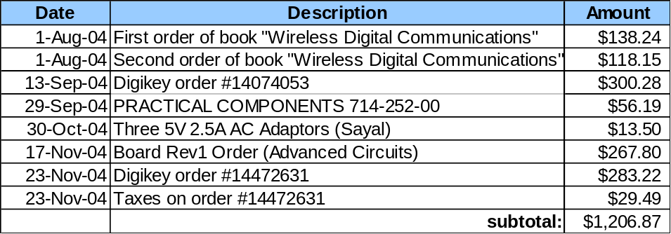

Projected Cost:

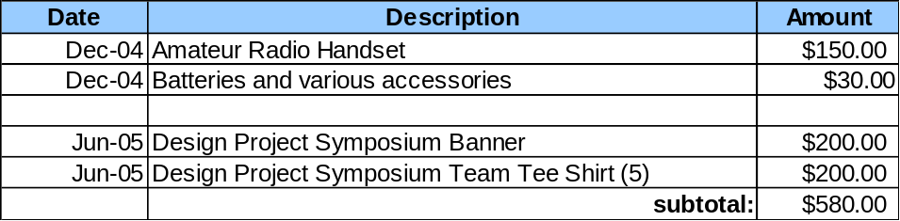

PHASE 1-4 Total: 1786.87

(Project phase 5)
This phase of the project is still at a planning stage. The completion of the phase will be determined at a later date depending on the availability of both parties involved and the funding allocated.

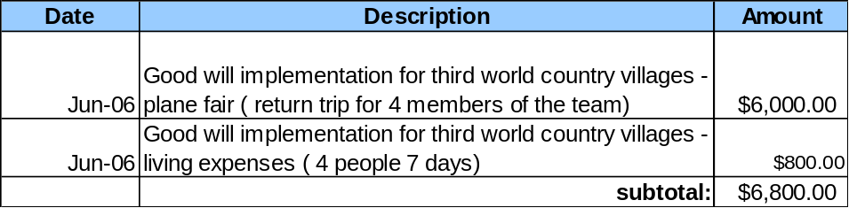

SPONSORSHIP PACKAGES AND BENEFITS

Package | Benefits to Sponsors | Sponsored amount
Bronze | - A 1 inch x 1 inch logo will be included on the Symposium display and the show tee-shirt.  - A special thank you speech will be delivered at the Symposium. | $500
Silver | - A 1 inch x 1 inch logo will be included on the Symposium display and the show tee-shirt.  - A special thank you speech will be delivered at the Symposium.  - A anniversary edition of MARCONI will be sent to the sponsor as a token of appreciation | $1000
Gold | - A 3 inch x 3 inch logo will be included on the Symposium display and the show tee-shirt.  - A special thank you speech will be delivered at the Symposium.  - A anniversary edition of MARCONI will be sent to the sponsor as a token of appreciation | $1500
Table 1 – Sponsorship Packages and Benefits outline

